**TEAM MEMBERS:**

Shaurya Srinet – RA2111032010006

Alok Agnihotri – RA2111032010010

K Ananya – RA2111032010011

Vaishnavi Kumari – RA2111032010017

Sangam Smilika Reddy– RA2111032010025

Shounak Chandra – RA2111032010026

**SOCIAL BUSINESS PLAN**

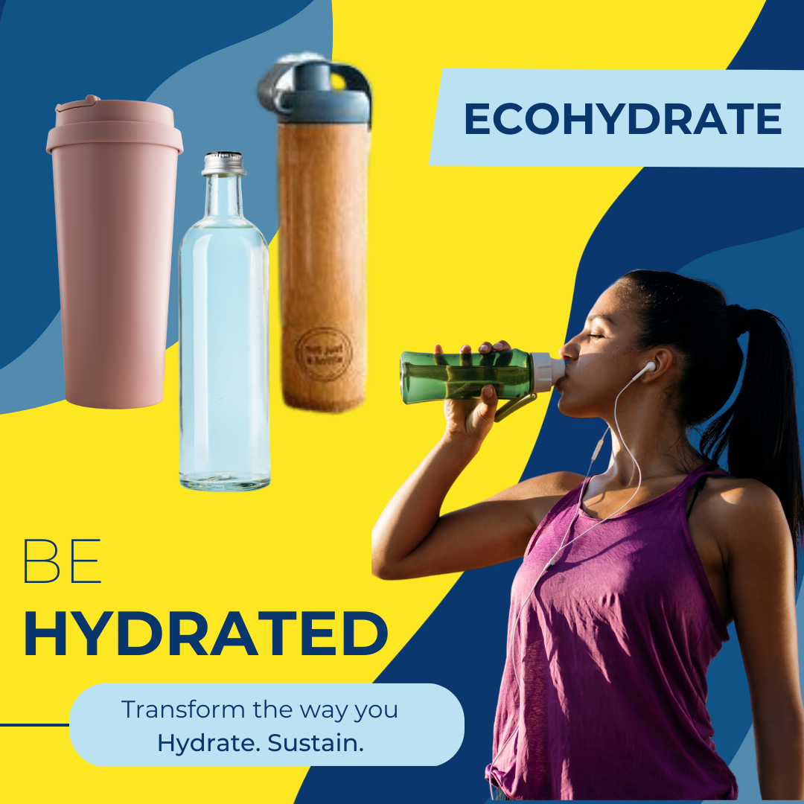

**Executive Summary:**

Our product is a sustainable, eco-friendly water bottle called "EcoHydrate" that promotes healthy hydration habits and reduces single-use plastic waste. EcoHydrate will be marketed to college students and sold both online and through partnerships with campus stores and sustainability-focused organizations.

**Market Analysis:**

College students are a growing market for eco-friendly products, with many students expressing concern about the environment and seeking out sustainable alternatives to traditional products. The water bottle market is also a large and growing market, with over $8 billion in revenue in 2020.

**Product Description:**

EcoHydrate is a high-quality, reusable water bottle made from eco-friendly materials such as bamboo, stainless steel, or recycled plastic. The bottle will feature a sleek, modern design and will come in a variety of colors and sizes to appeal to a wide range of customers. The bottle will be marketed as a sustainable, eco-friendly alternative to traditional plastic water bottles and will be priced competitively.

**Marketing and Sales:**

Marketing efforts will focus on social media and online advertising, as well as partnerships with sustainability-focused organizations and campus stores. EcoHydrate will be sold both online and through brick-and-mortar stores, with a focus on building a strong brand identity and cultivating a loyal customer base.

**Management Team:**

EcoHydrate will be led by a team of experienced entrepreneurs with backgrounds in sustainability, marketing, and business management. The team will be responsible for overseeing product development, marketing and sales, and finance and operations.

**Financial Projections:**

Initial investment for EcoHydrate is estimated to be $250,000, with the majority of funding going towards product development, marketing, and staffing costs. Revenue projections are based on sales revenue, with the goal of generating $500,000 in revenue by the end of year 2.

**Social Impact:**

EcoHydrate aims to promote healthy hydration habits and reduce single-use plastic waste, with the goal of reducing the environmental impact of plastic pollution. The company will work to educate consumers about the benefits of reusable water bottles and sustainable living practices, with the aim of promoting a more sustainable and eco-friendly future.

In summary, EcoHydrate is a sustainable, eco-friendly water bottle designed to promote healthy hydration habits and reduce single-use plastic waste. The bottle is made from eco-friendly materials like bamboo, stainless steel, or recycled plastic, and features a modern design in a variety of colors and sizes. It is marketed as a sustainable alternative to traditional plastic water bottles and aimed at college students. EcoHydrate is sold both online and in brick-and-mortar stores, and the company aims to promote sustainable living practices and reduce plastic pollution.